**INTI International College Penang School of Engineering and Technology**

**3+0 Bachelor of Science (Hons) in Computer Science, in collaboration with Coventry University, UK**

**3+0 Bachelor of Science (Hons) in Computing, in collaboration with Coventry University, UK**

**Coursework cover sheet**

**Section A - To be completed by the student**

|  |  |
| --- | --- |
| Full Name: SATISH A/L PRAKASHAM | |
| CU Student ID Number: P22014510 | |
| Semester: 1 | |
| Session:  **August 2022** | |
| Lecturer:  **Nadhrah Abdul Hadi (nadhrah.abdulhadi@newinti.edu.my)** | |
| Module Code and Title:  **4067CEM Software Design** | |
| Assignment No. / Title:  **Continuous Assessment** | % of Module Mark:  **50** |
| Hand out Date:  **6th September 2022** | Due Date:  **Task 1: 30 September 2022, by 11.59pm.**  **Task 2: 18 November 2022, by 11.59pm**  **Task 3: 18 November 2022, by 11.59pm.**  **Task 4: 18 November 2022, by 11.59pm.**  **Task 5: 18 November 2022, by 11.59pm.** |
| Penalties: No late work will be accepted. If you are unable to submit coursework on time due to extenuating circumstances, you may be eligible for an extension. Please consult the lecturer. | |
| Declaration: I/we the undersigned confirm that I/we have read and agree to abide by the University regulations on plagiarism and cheating and Faculty coursework policies and procedures. I/we confirm that this piece of work is my/our own. I/we consent to appropriate storage of our work for plagiarism checking.  Signature(s): ________________________ | |

**Section B - To be completed by the module leader**

|  |  |  |
| --- | --- | --- |
| Intended learning outcomes assessed by this work:  1. Understand and apply appropriate concepts, tools and techniques to each stage of the software development  2. Understand and apply design patterns to software components in developing new software  3. Demonstrate an understanding of project planning and working to agreed deadlines, along with professional, interpersonal skills and effective communication required for software production  5. Demonstrate an awareness of, and ability to apply, social, professional, legal and ethical standards as documented in relevant laws and professional codes of conduct such as that of the Malaysian National Computer Confederation. | | |
| Marking scheme | Max | Mark |
| 1. User Story Mapping 2. Setting up a GitHub Repository 3. Creating a Class diagram and design pattern selection 4. Creating a Prototype User Interface and Usability Testing 5. Discuss the ethical issue related to the software | 20  10  30  20  20 |  |
| Total | 100 |  |

# **Task 4 – Creating a Prototype User Interface and Usability Testing (20 marks)**

Create a Prototype User Interface (hand drawn/digital) of TWO (2) important functions of the proposed system. Come up with a usability testing questions. You don’t have to carry out the test, just prepare the questions. You should indicate what you are testing for in the Usability Testing.

Output – A Prototype and Usability Testing Questions. In Word format, uploaded to GitHub. Please include the coverpage (both Section A and Section B)

Due – Week 13 of the semester. 18 November 2022, by 11.59pm

***Task 4***

Feature 1 = Mini Games

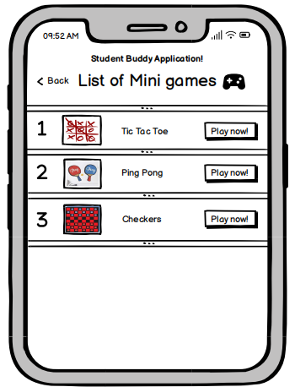

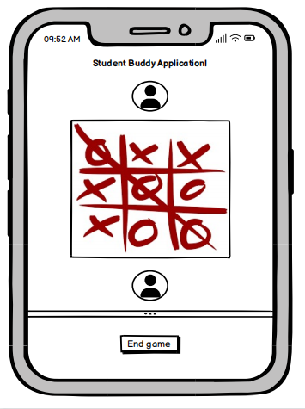Figure 1 shows the list of mini games provided in the application.

Figure 2 shows a user playing tic tac toe with another user

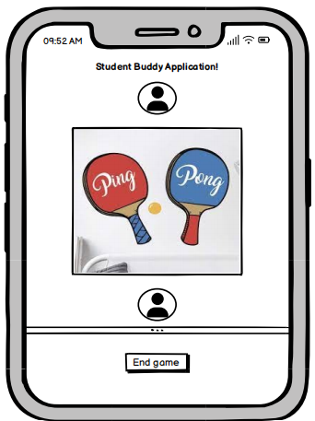

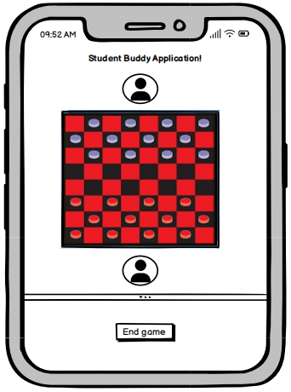Figure 3 shows a user playing ping pong with another user

Figure 4 shows a user playing checkers with another user

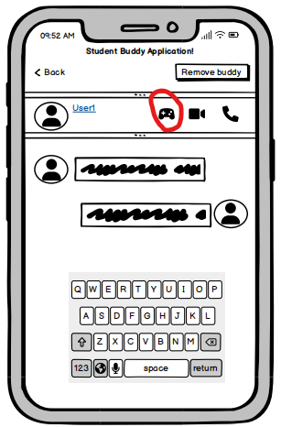

Figure 5 shows the location where the mini games can be accessed

One of the main feature that I have included in the Student Buddy Application is the mini games feature. Including the mini game feature in the application can help the users in various ways. First and foremost, it will allow users to engage with one another by playing mini games. The mini game feature can also help to strengthen the bond of between one another whereas playing mini games can provide quality time between the users. On the other hand, the mini game feature can be platform where the users can be stress free. Most importantly, with the mini game feature users would not get bored by just chatting with one another because the users have a mini game feature where the users can have fun at.

The mini game feature can be accessed in the chat room of every buddy that is in the buddy list. The mini game feature is added into the chat room and not as a separate page. This is mainly because it is more convenient for the users. The users can click the the Game pad icon in the chat room as circled in Figure 5 to view the list of mini games in the application. The list of mini games are shown in Figure 1. There are total three games provided in the mini games. Which is “Tic Tac Toe”, “Ping Pong” and “Checkers”. If the user wish to play “Ping Pong’” with the a specific user, then the user can open the chat room of the specific user and click the game pad icon and click the play button beside the label “Ping Pong”. The user will be playing “Ping Pong” with the specific user as shown in Figure 3. The same accessing method is applied to all the mini games.

Feature 2 = Remove Buddy

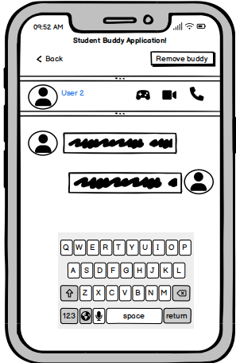

Figure 7 shows where the location of remove buddy feature

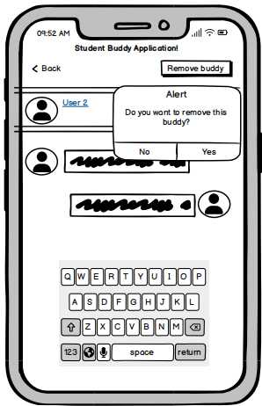

Figure 8 shows the alert after clicking the Remove buddy button

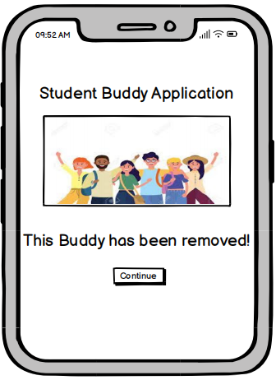

Figure 9 shows the message after removing the buddy

The second feature that has been included in the Student Buddy Application is the remove buddy feature. This feature can be very helpful when a user is facing another user who is behaving in a disturbing manner. Removing a buddy can help to prevent any further disturbance from the user. This feature can be accessed in the chat room. The Remove buddy feature is located on the top right of every chat room. The location of remove buddy feature is shown in Figure 7. The feature is a button labeled as “Remove buddy”. Upon clicking the button, a confirmation alert will be shown to confirm the removal of the buddy. This is because, after the removal of the buddy the user would not be able to have any access with the buddy that is removed. The confirmation alert is shown is Figure 8. If the user click “Yes” the buddy will be removed from the buddy list and there will be no access with the buddy anymore. Upon clicking “Yes” the confirmation message will show up. Shown in Figure 9. If the user click “No” then the buddy will not be removed from the buddy list and will still have access with one another.

***Usability Testing Questions***

1. Is the application easy to use?
2. Do you like the interface?
3. Do you find the application interesting?
4. Do you like the mini game feature?
5. Do you think this application can benefit the people in college?
6. Does the application fulfill your expectations?
7. Do you find the application silly?
8. The graphic elements makes the application silly?
9. Have you used a Student Buddy System application before?
10. Have you tried to make college friends?
11. Do you think the functions in the applications are well integrated?
12. Is the application consistent to your liking?
13. Do you have a friend in college that is not in the same class with you?
14. Would you recommend this application to someone?
15. Would you use this application?